LAB ASSIGNMENT-2
DDL QUESTIONS (Data Definition Language)
1. Create table CLASS with appropriate data types
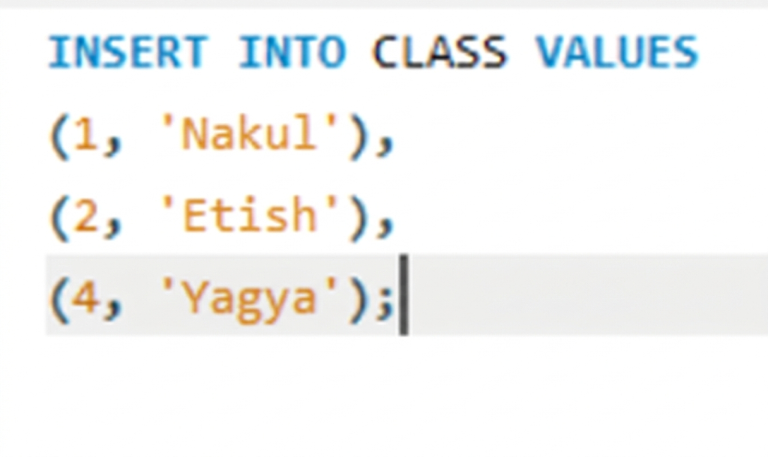
OUTPUT:
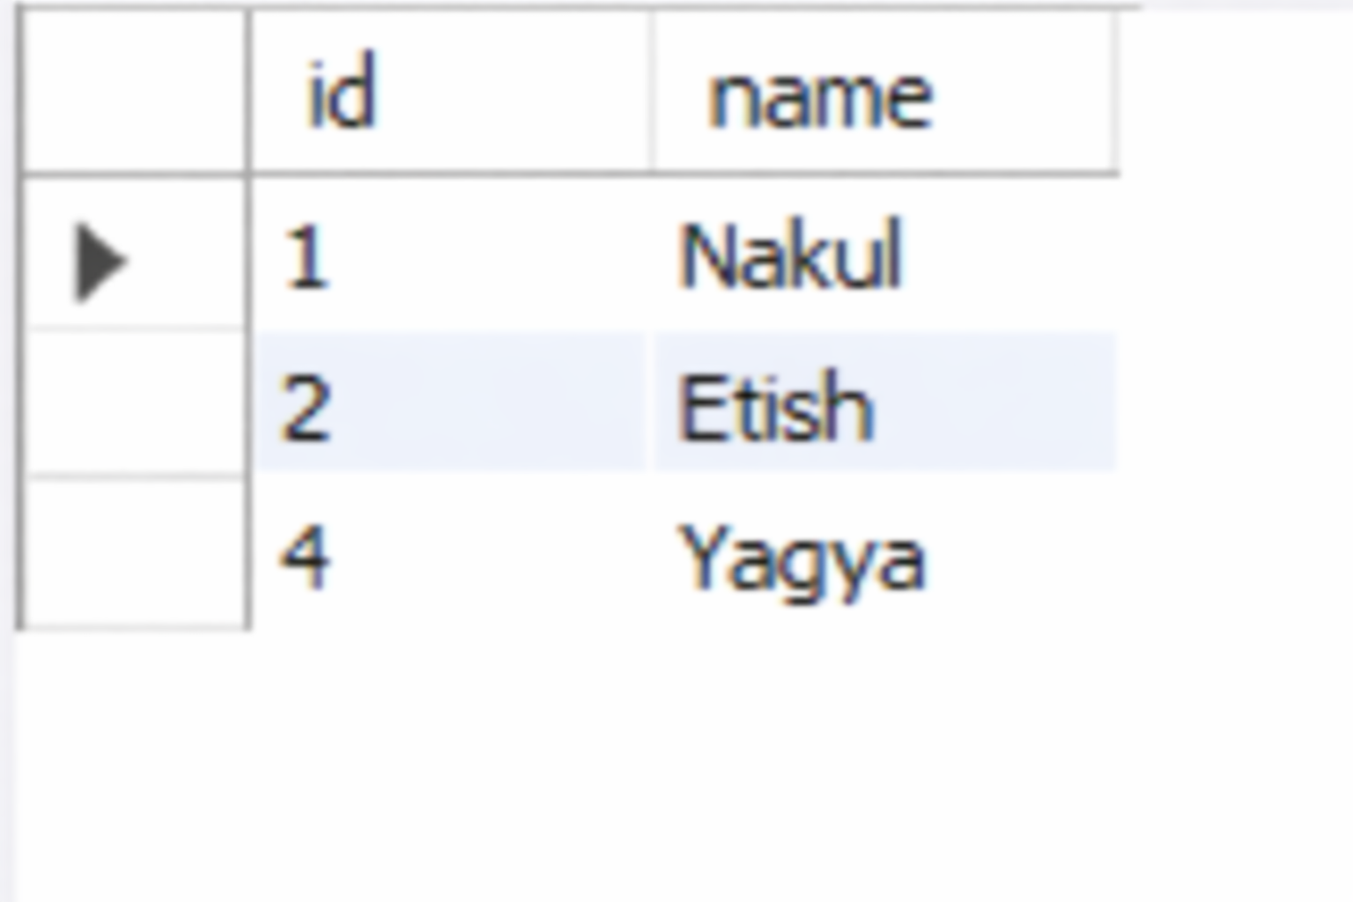
2. Create table EMPLOYEES with specified attributes
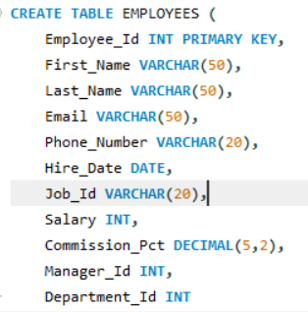
OUTPUT:
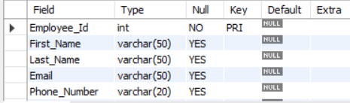

3.Create table Client_master with specified attributes
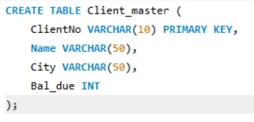
OUTPUT:

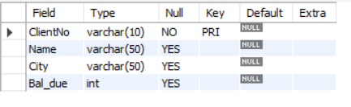
4.Rename table Client_master to Client12
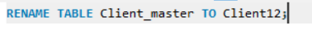
OUTPUT:
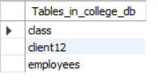
5.Display bal_due column heading as “BALANCE”
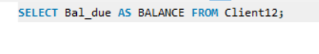
OUTPUT:
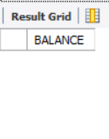
DML QUESTIONS (Data Manipulation Language)
Part A: Transactions and Savepoints (CLASS Table)
1. Insert + Commit
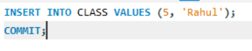
OUTPUT:
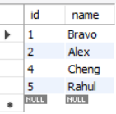

2. Update + Savepoint A
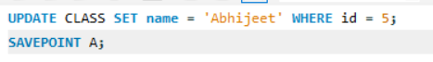

OUTPUT:
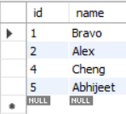

3. Insert + Savepoint B
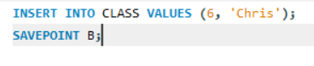
OUTPUT:
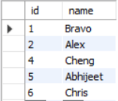

4. Insert + Savepoint C
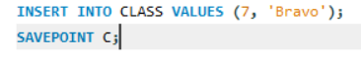
OUTPUT:
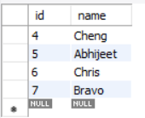
5. Rollback to Savepoint B
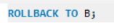
OUTPUT:
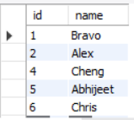

6. Rollback to Savepoint A
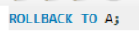
OUTPUT:
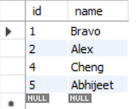

PART B: Retrieving Records (EMPLOYEES Table)
1.Find out the employee id, names, and salaries of all the employees.
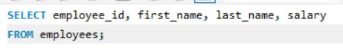

OUTPUT:
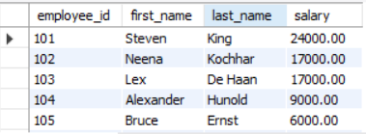

2.List out the employees who work under manager 100.
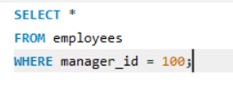
OUTPUT:
3.Find the names of the employees who have a salary greater than or equal to 4800.
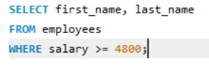
OUTPUT:
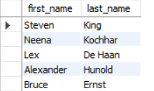
4.List out the employees whose last name is ‘AUSTIN’.
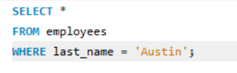
OUTPUT:

5.Find the names of the employees who work in departments 60, 70, and 80.
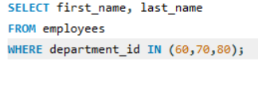
OUTPUT:
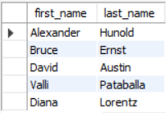

6.Display the unique Manager_Id.
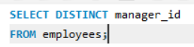

OUTPUT:
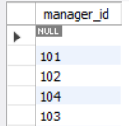

PART C: Updating Records (Client_master Table)
1.Insert five records into the Client_master table.
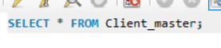
OUTPUT:
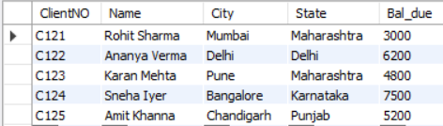

2.Find the names of clients whose bal_due &gt; 5000.
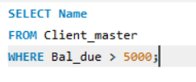
OUTPUT:
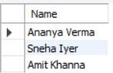
3.Change the bal_due of ClientNO &quot;C123&quot; to Rs. 5100.
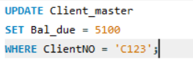
OUTPUT:
